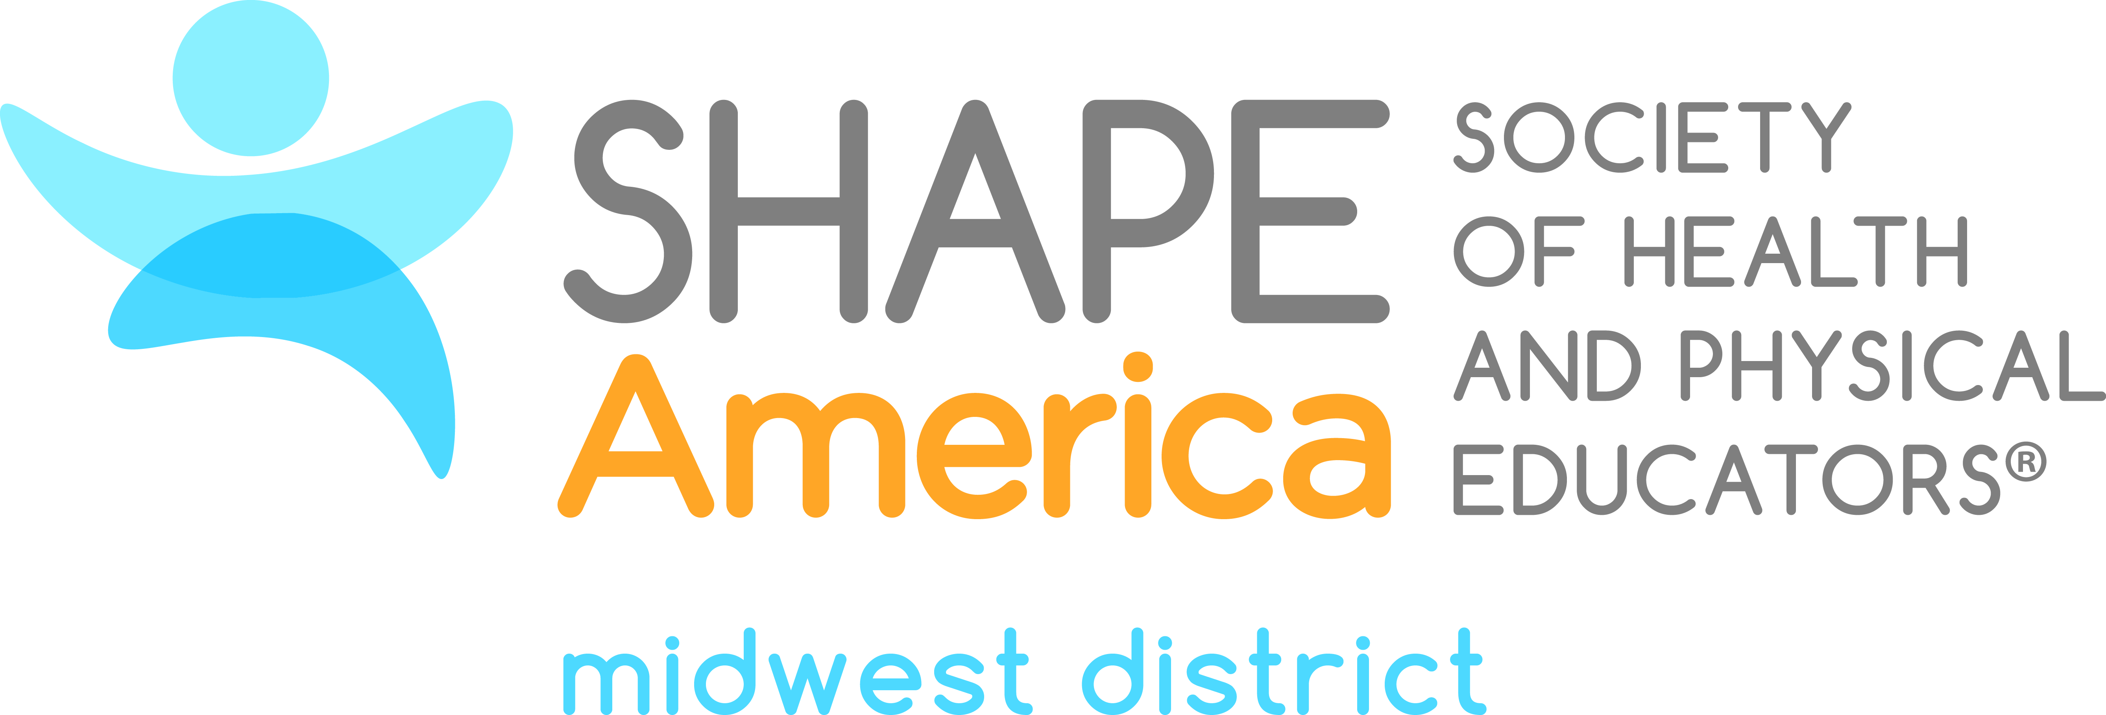

2019 Candidate for the Office of President-Elect

Patty Kestell
Thornson Elementary School
Cedarburg, WI

Patty Kestell received her undergraduate and master’s degrees from the University of Wisconsin-LaCrosse and UW-Whitewater. She has dedicated the past 28 years of her teaching career serving students and families in Cedarburg School District. She has taught at the elementary, middle school and high school levels throughout the early years of her career and has now spent the past 16 years at Thorson Elementary School. Patty has served as her district’s Student/Staff Wellness and Health Coordinator, and currently serves as the Health and Physical Education Curriculum Liaison and on her school’s PBIS and Leadership teams.

In an effort to give back to the HPE profession, Patty has served in various leadership roles in WHPE, Midwest District, and SHAPE America. Patty is the Past President of WHPE President (2016-2018: Building Strong Connections- Educate. Engage. Advocate) and has served as WI State JRFH/HFH Coordinator; WHPE Elementary VP; Midwest District VP of the Sport, Dance, and PE Council; Midwest District Board of Director member; and as a WHPE, Midwest District, and SHAPE America Awards committee member.

Among various accomplishments, Patty received the WI Herb Kohl Teacher Fellowship Award in 1995. In 2012, she was honored with the Cedarburg School District Extra Distance Award, as well as the WHPE and Midwest District Elementary Physical Education Teacher of the Year. In 2013, Patty was recognized as the National Elementary PE TOY and AAHPERD/SHAPE America National Jump Rope for Heart Coordinator. She was most recently honored with the 2017 WHPE Honor Award.

Vision Statement for SHAPE America Midwest District

Innovate, Collaborate, Rejuvenate…Shaping the Future of Midwest!

Our greatest strength as Midwest District SHAPE lies within our members, association leaders,
and health and physical education professionals who have committed themselves to serving,
educating, and advocating for their students and communities. We need to capitalize on
the wealth of knowledge that our colleagues from Midwest District have to offer to our profession,
each other, and other SHAPE districts across the country.

I am excited to support the 2018-2019 Midwest District SHAPE goals that have been set forth,
and to highlight programs and initiatives that each state is working on, using social media and
other communication tools to connect, network and collaborate with each other.

It is a critical time for Midwest District SHAPE to reestablish a variety of new professional
development opportunities for its members and future professionals, and to provide health and
physical educators with the educational tools, resources, and advocacy skills they need to
help their students lead healthy and physically active lives.

